

**T.C**

**YILDIZ TECHNICAL UNIVERSITY**

**FACULTY OF MECHANICAL ENGINEERING**

**DEPARTMENT OF INDUSTRIAL ENGINEERING**

**SCHEDULING HOMEWORK**

|  |  |  |
| --- | --- | --- |
|  | Student ID | Name & Surname |
| 1) | 17061025 | Meltem GÜLŞEN |
| 2) | 19061602 | Şevval Begüm DEMİREL |
| 3) | 19061605 | Senanur DEMİR |
| 4) | 15069902 | Burak KAPLAN |
| 5) | 15065020 | Gizem BÜLBÜL |

***CONTENTS***

*1. OUR HEURISTIC METHODOLOGY 1*

*2. BRANCH & BOUND ALGORITHM 3*

*3. CDS ALGORITHM 8*

*4. COMPARISON BETWEEN ALGORITHMS 11*

1. **OUR HEURISTIC METHODOLOGY**

|  |  |  |  |
| --- | --- | --- | --- |
|  | M1 | M2 | M3 |
| J1 | 27 | 10 | 8 |
| J2 | 12 | 9 | 10 |
| J3 | 11 | 10 | 8 |
| J4 | 8 | 13 | 12 |
| J5 | 14 | 12 | 9 |

**Step 1:**In our heuristic methodology, we determine that the difference between each jobs individual process time at each machineincrease our process time so we try to sort the jobs ascending order based on their each machine process time.

PDJX = job x’s process time difference.

The differences shown below.

|  |  |  |  |
| --- | --- | --- | --- |
|  | M1-M2 | M2-M3 | Differences at process times |
| J1 | |27-10| = 17 | |10-8| = 2 | PDJ1 = 19 |
| J2 | |12-9| = 3 | |9-10| = 1 | PDJ2 = 4 |
| J3 | |11-10| = 1 | |10-8| = 2 | PDJ3 = 2 |
| J4 | |8-13| = 5 | |13-12| = 1 | PDJ4 = 6 |
| J5 | |14-12| = 2 | |12-9| = 3 | PDJ5 = 5 |

The ascending order,

J1 – J4 – J5 – J2 – J3

**Step 2 :**Then we set our second criteria. We assign first the jobs that have minimum process time at M3. Because the jobs must be done at M1 and M2 before going to M3. So if we assign the job first place who has maximum process time at M3, the machine’s idle time can be minimize.

PM3JX = job x’s process time at machine 3.

PM3J1 = 8

PM3J2 = 10

PM3J3 = 8

PM3J4 = 12

PM3J5 = 9

When we look at the M3 process time for each job and sort them, the result,

J4 – J2 – J5 – J1 – J3 or

J4 – J2 – J5 – J3 – J1

**Step 3 :**To combine this results, we use priority point. The lower the score, the higher the priority, because the number means that it should be first to be assigned.

J1 – J4 – J5 – J2 – J3 J4 – J2 – J5 – J1 J3

1 2 3 4 5 1 2 3 4 4

**Step 4 :** We are going to add every jobs priority point, then we are going to sort them based on points.

PPJX = job x’ priority point

|  |  |
| --- | --- |
| J1 | PPJ1= 1+4=5 |
| J2 | PPJ2 =4+2=6 |
| J3 | PPJ3= 5+4=9 |
| J4 | PPJ4 =2+1=3 |
| J5 | PPJ5 = 3+3=6 |

The order,

J4 – J1 – J2 – J5 – J3 or

J4 – J1 – J5 – J2 – J3

**Step 5 :** Now we are going to calculate each order’s process times with Gannt diagram. And select the order with minimum process time.

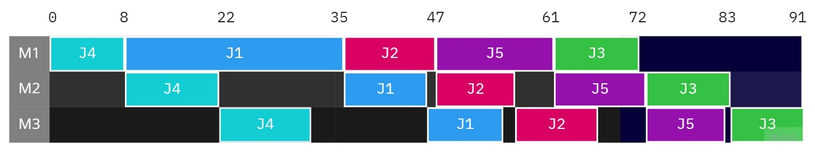

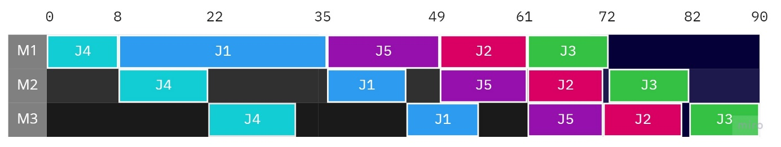

We can see clearly that J4 – J1 – J5 – J2 – J3 order’s process time minimum. Our result is 90 process time.

1. **BRANCH & BOUND ALGORITHM**

We have 5 jobs and 3 machines in the problem (5/3/F/Cmax). Branch & bound scheme can be seen below.

We start calculating lower bound on every nodes of the Cmax according to 12345 sequence. The way followed is XXXXX, to 1XXXX , to 12XXX, then 123XX and finally to 12345.

The formulas used are;

αi(k)= αi(k-1)+ ai(k)

β i(k)= max{αi(k), β i(k-1)}

γi(k)= max{β i(k), γ i(k-1)}

Ib(A)= max{αi(k)+Σai+ min(bi+ci), β i(k)+ Σbi+ min(ci), γi(k) + Σci}

According to our calculations with formulas above, we get results:

**When Job 1 is first;**

Cmax

**1XXXX : 45**

12XXX: 58 Cmax Cmax

123XX: 68 124XX: 73 125XX: 74

12345: 94 12435: 93 12534: 100

12354: 101 12453: 91 12543: 98

13XXX: 56

132XX: 69 134XX: 73 135XX: 73

13245: 93 13425: 93 13524: 98

13254: 101 13452: 92 13542: 99

14XXX: 62

142XX: 72 143XX: 70 145XX: 71

14235: 93 14325: 93 14523: 90

14253: 91 14352: 91 14532: 91

15XXX: 62

152XX: 72 153XX: 71 154XX: 78

15234: 99 15324: 98 15423: 96

15243: 95 15342: 98 15432: 96

**When Job 2 is first;**

Cmax

**2XXXX : 31**

21XXX: 57 Cmax Cmax

213XX: 68 214XX: 74 215XX: 74

21345: 94 21435: 93 21534: 100

21354: 101 21453: 92 21543: 98

23XXX: 41

231XX: 68 234XX: 58 235XX: 58

23145: 94 23415: 93 23514: 99

23154: 101 23451: 90 23541: 90

24XXX: 46

241XX: 65 243XX: 54 245XX: 55

24135: 91 24315: 91 24513: 90

24153: 93 24351: 90 24531: 90

25XXX: 47

251XX: 71 253XX: 56 254XX: 64

25134: 99 25314: 99 25413: 90

25143: 96 25341: 90 25431: 90

**When Job 3 is first;**

Cmax

**3XXXX :** **29**

31XXX: 56 Cmax Cmax

312XX: 69 314XX: 73 315XX: 73

31245: 93 31425: 93 31524: 98

31254: 101 31452: 92 31542: 99

32XXX: 42

321XX: 68 324XX: 57 325XX: 58

32145: 94 32415: 93 32514: 99

32154: 101 32451: 90 32541: 90

34XXX: 46

341XX: 64 342XX: 56 345XX: 55

34125: 93 34215: 93 34512: 91

34152: 91 34251: 90 34521: 90

35XXX: 46

351XX: 70 352XX: 56 354XX: 62

35124: 98 35214: 99 35412: 91

35142: 97 35241: 90 35421: 90

**When Job 4 is first;**

Cmax

**4XXXX : 33**

41XXX: 53 Cmax Cmax

412XX: 66 413XX: 64 415XX: 70

41235: 93 41325: 93 41523: 90

41253: 91 41352: 91 41532: 91

42XXX: 33

421XX: 65 423XX: 51 425XX: 55

42135: 93 42315: 93 42513: 90

42153: 91 42351: 90 42531: 90

43XXX: 41

431XX: 64 432XX: 51 435XX: 54

43125: 93 43215: 93 43512: 91

43152: 91 43251: 90 43521: 90

45XXX: 43

451XX: 67 452XX: 53 453XX: 52

45123: 90 45213: 90 45312: 91

45132: 91 45231: 90 45321: 90

**When Job 5 is first;**

Cmax

**5XXXX : 35**

51XXX: 59 Cmax Cmax

512XX: 72 513XX: 70 514XX: 76

51234: 99 51324: 98 51423: 94

51243: 95 51342: 97 51432: 94

52XXX: 45

521XX: 71 523XX: 55 524XX: 60

52134: 99 52314: 99 52413: 90

52143: 96 52341: 90 52431: 90

53XXX: 44

531XX: 70 532XX: 56 534XX: 61

53124: 98 53214: 99 53412: 91

53142: 97 53241: 90 53421: 90

54XXX: 51

541XX: 67 542XX: 61 543XX: 59

54123: 90 54213: 90 54312: 91

54132: 91 54231: 90 54321: 90

All these calculations take into consideration,

Optimal order for problem is;

**32451**

Optimal order is shown as coloured in the scheme;

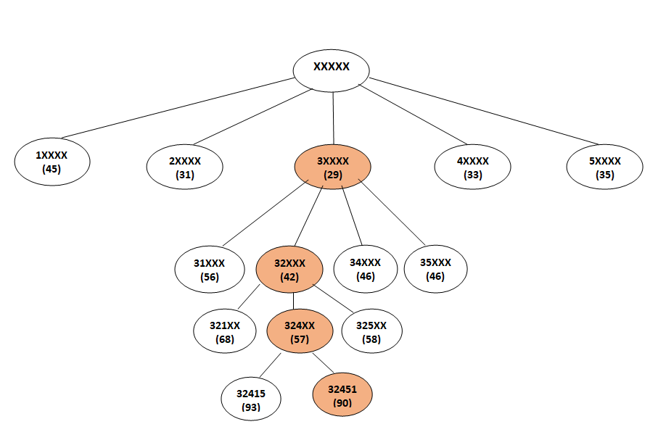

1. **CDS ALGORITHM**

|  |  |  |  |
| --- | --- | --- | --- |
|  | M1 | M2 | M3 |
| J1 | 27 | 10 | 8 |
| J2 | 12 | 9 | 10 |
| J3 | 11 | 10 | 8 |
| J4 | 8 | 13 | 12 |
| J5 | 14 | 12 | 9 |

To solve this flow shop problem with the CDS algorithm, it is first necessary to find out how many sub-problems there are.Since there are 3 machines(m=3), m-1 = 2 sub problems arise.

Sub problem 1:The M1 machine is thought of as the M1 'puppet machine, the M3 machine as the M2' puppet machine.Sortingis done by applying Johnson rule.

|  |  |  |
| --- | --- | --- |
|  | M1'=M1 | M2'=M3 |
| J1 | 27 | 8 |
| J2 | 12 | 10 |
| J3 | 11 | 8 |
| J4 | 8 | 12 |
| J5 | 14 | 9 |

**4-2-5-3-1 and 4-2-5-1-3**

Tabulated representation of routed network and sequence:

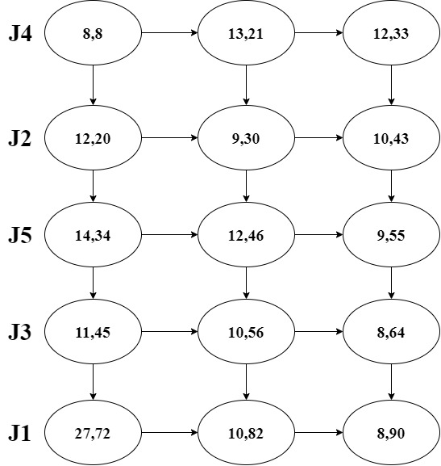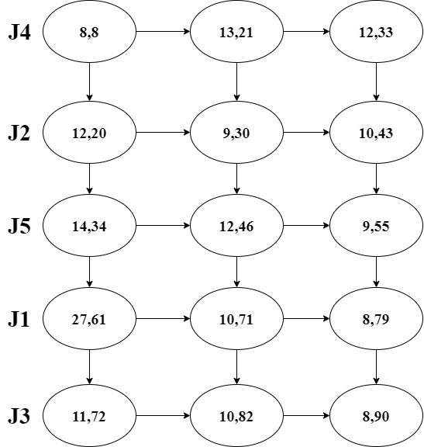

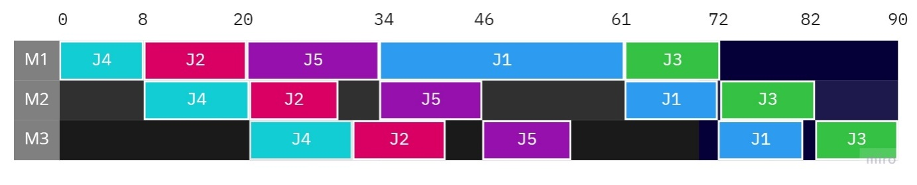

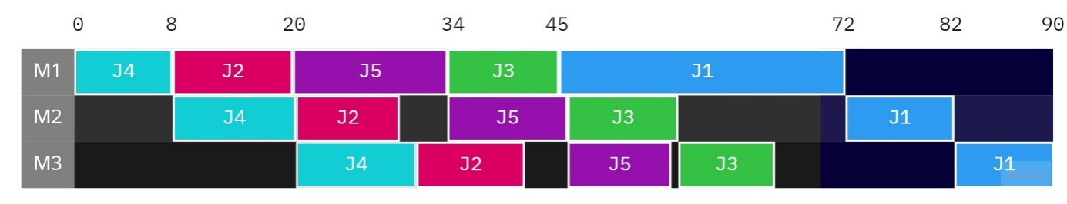

Sub problem 2:Using the data in the problem, the second sub-problem is obtained as follows.

|  |  |  |
| --- | --- | --- |
|  | M1'=M1+M2 | M2'=M2+M3 |
| J1 | 37 | 18 |
| J2 | 21 | 19 |
| J3 | 21 | 18 |
| J4 | 21 | 25 |
| J5 | 26 | 21 |

**4-5-2-3-1 and 4-5-2-1-3**

Tabulated representation of routed network and sequence:

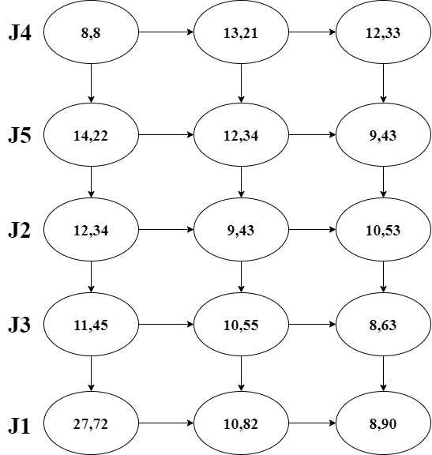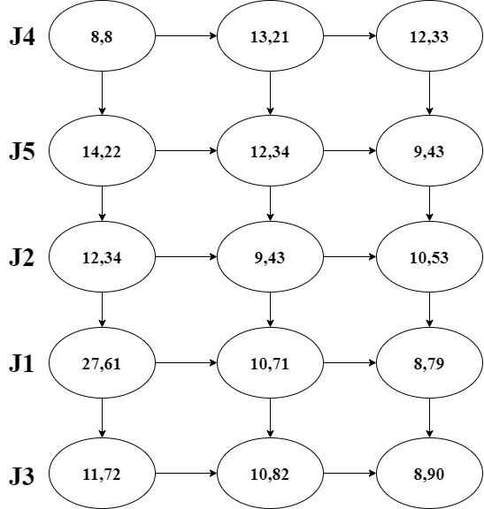

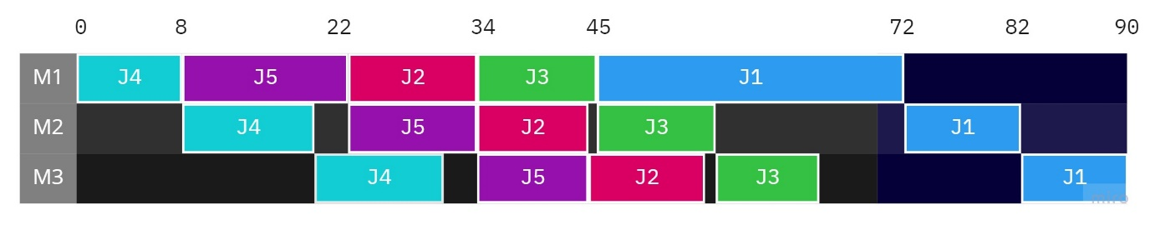

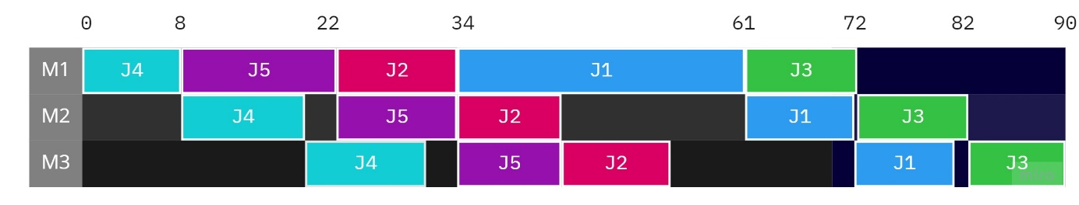

1. **COMPARISON BETWEEN ALGORITHMS**

|  |  |  |  |
| --- | --- | --- | --- |
|  | **Our heuristic methodology** | **Branch&bound algorithm** | **CDS algorithm** |
| **Sequences** | 4 – 1 – 5 – 2 – 3 | 3 – 2 – 4 – 5 – 1 | 4 – 5 – 2 – 1 – 3 |
| **Optimal Cmax** | 90 | 90 | 90 |
| **Comparison** | - | $$\frac{90-90}{90}=0$$ | $$\frac{90-90}{90}=0$$ |
| **Efficiency** | 100% | 100% | 100% |

There is no difference in terms of efficiency between our methodology and branch&bound, CDS algorithm.

The reason why the order in the CDS algorithm is different with our heuristic method is that while prioritizing the processing time on the last machine and giving the least priority to the first machine, while the first machine is more important in the CDS algorithm, the processing time of the last machine is the least important.

The optimum result does not change, but the order has changed.

Despite our heuristic methodology we obtain same as with these algorithms but we can not say that our methodology always gives best solution, because of being heuristic.

If the problem complexity increases, we may not obtain the optimal solution.

Although various methods are used in this assignment, we realized that it is possible to achieve the optimum result. When choosing the heuristic method, attention should always be paid to the machine and the job that requires the longest time.